**CLASSIFICATION OF 41 HAND AND WRIST MOVEMENTS VIA SURFACE ELECTROMYOGRAM USING DEEP NEURAL NETWORK**

**ABSTRACT**

A simple and non-invasive method of enabling the user to actively operate the prosthesis is surface electromyography (sEMG). However, the categorization of hand and wrist movements using sEMG has produced a wide range of results in prior investigations a number of elements, including the acquisition protocol and the number of classes, but not exclusively. In order to classify 41 hand and wrist movements based on the sEMG data, the deep neural network approach is being investigated in this paper. One of the largest public sEMG databases for cutting-edge hand myoelectric prosthetics, the Ninapro project's database was used to train and assess the proposed models. Two datasets, DB5 with a low-cost 16-channel, 200-Hz setup and DB7 with a 12-channel, 2 kHz arrangement, were used for this research. With a balanced accuracy of 84.00 3.40 and 84.66 4.78% for DB5 and DB7, our method attained an overall accuracy of 93.87 1.49 and 91.69 4.68% respectively. The six primary hand motions based on the six prehensile patterns from the Southampton Hand Assessment Procedure (SHAP), a clinically established hand functional assessment protocol, were the only movements taken into account, yet we still noticed a performance improvement. A balancing accuracy of 94.48 2.55% and a classification accuracy of 98.82 0.58% were achieved using simply the SHAP movements in DB5. On data from one of the amputee participants in DB7, our model also achieved an overall accuracy of 99.00% with a balanced accuracy of 91.27% using the identical set of actions. These findings indicate that our concept could be a promising method for controlling adaptable prosthetic hands with a wide variety of predetermined hand and wrist movements with additional information on the amputee patients.

**Keywords**: Surface Electromyogram, Hand Movement Classification, Deep Neural Network, Prosthetic Hand, Ninapro Database.

**LITERATURE REVIEW**

**[1] Ahmadizadeh, C., Merhi, L.-K., Pousett, B., Sangha, S., and Menon, C. (2017):** Despite the appearance of advanced multi-degrees of freedom (DoF) robotic hands during the past decade, prosthetic control lacks a powerful interface to facilitate all its functionalities in a manner that is acceptable for a majority of users. In this article, we explore the feasibility of using a sensing technique called force myography (FMG) as an alternative or synergist to the traditional surface electromyography (sEMG) technique as a human-machine interface (HMI) for the control of a multi-DoF prosthetic hand, bebionic 3 by Ottobock, Austin, Texas. In this article, we present a prosthetic prototype developed for the Cybathlon 2016, a championship for racing pilots with disabilities using assistive robotic devices. The design of the prototype is discussed and the effect of two factors on its control is analyzed. These factors are 1) the impact of a multisensory approach and 2) the placement of FMG sensor strips within the prosthetic inner socket. Analysis is performed by comparing resulting pattern recognition accuracies.

**Summary**: Studied about the Toward Intuitive Prosthetic Control: Solving Common Issues Using Force Myography, Surface Electromyography, and Pattern Recognition in a Pilot Case Study.

**[2] Ahmadizadeh, C., Pousett, B., and Menon, C. (2019):** In this case study, three datasets were used. These datasets were collected from force sensitive resistors embedded in the inner socket of a subject with transradial amputation. Sensor data were collected as the subject carried out five repetitions of six gestures. Collected data were then used to asses five CS methods: Sequential forward selection (SFS) with two different stopping criteria, minimum redundancy-maximum relevance (mRMR), genetic algorithm (GA), and Boruta.

Three out of the five methods (mRMR, GA, and Boruta) were able to decrease channel numbers significantly while maintaining classification accuracy in all datasets. Neither of them outperformed the other two in all datasets. However, GA resulted in the smallest channel subset in all three of the datasets. The three selected methods were also compared in terms of stability [i.e., consistency of the channel subset chosen by the method as new training data were introduced or some training data were removed.

**Summary:** Studied about the Investigation of Channel Selection for Gesture Classification for Prosthesis Control Using Force Myography: A Case Study.

**[3] Ameri, A., Akhaee, M. A., Scheme, E., and Englehart, K. (2018)**: The evolution of deep learning techniques has been transformative as they have allowed complex mappings to be trained between control inputs and outputs without the need for feature engineering. In this work, a myoelectric control system based on convolutional neural networks (CNN) is proposed as a possible alternative to traditional approaches that rely on specifically designed features. This CNN-based system is validated using a real-time Fitts' law style target acquisition test requiring single and combined wrist motions. The performance of the proposed system is then compared to that of a standard support vector machine (SVM) based myoelectric system using a set of time-domain features. Despite the prevalence and demonstrated performance of these well-known features, no significant difference (p>0.05) was found between the two methods for any of the computed control metrics. This demonstrates the potential for automated learning approaches to extract complex and rich information from stochastic biological signals. This first evaluation of the usability of a CNN in a real-time myoelectric control environment provides a basis for further exploration.

**Summary:** Studied about Real-time, simultaneous myoelectric control using a convolutional neural network.

**[4] Atzori, M., Gijsberts, A., Castellini, C., Caputo, B., Mittaz Hager, A.-G., Elsig, S., et al. (2014):** Recent advances in rehabilitation robotics suggest that it may be possible for hand-amputated subjects to recover at least a significant part of the lost hand functionality. The control of robotic prosthetic hands using non-invasive techniques is still a challenge in real life: myoelectric prostheses give limited control capabilities, the control is often unnatural and must be learned through long training times. Meanwhile, scientific literature results are promising but they are still far from fulfilling real-life needs. This work aims to close this gap by allowing worldwide research groups to develop and test movement recognition and force control algorithms on a benchmark scientific database. The database is targeted at studying the relationship between surface electromyography, hand kinematics and hand forces, with the final goal of developing non-invasive, naturally controlled, robotic hand prostheses. The validation section verifies that the data are similar to data acquired in real-life conditions, and that recognition of different hand tasks by applying state-of-the-art signal features and machine-learning algorithms is possible.

**Summary:** Studied about Electromyography data for non-invasive naturally-controlled robotic hand prostheses.

**EXISTING METHOD**

This paper presents a Deep Neural Network approach for the classification of 41 hand, wrist, grasping and functional movements based on a public dataset of low-cost sEMG sensors called Ninapro DB5. The recent advancements in sensor technology, mechatronics, signal processing techniques and edge computing hardware equipped with GPU make dexterous prosthetic hands with non-invasive sEMG sensors and control capabilities of machine learning possible. However, its high cost means the technology is not accessible to most people. Therefore, the objective of this paper is to investigate the control and capabilities of a low-cost setup of sEMG sensors for a prosthetic hand. The acquisition setup includes two Thalmic Myo armbands for the total of 16 channels with the sampling rate of 200 Hz. Our approach achieved an overall accuracy of 91% with a macro recall of 77% for the classification of 41 movements, outperformed other algorithms such as SVM, Random forest, and XGBoost. These results suggest that a development of practical prosthetic hand could be possible with low-cost sEMG sensors.

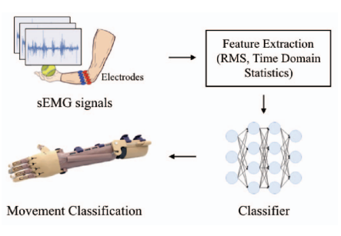

**Fig: Block Diagram of Existing Method**

**Deep Neural Network (DNN)**

The proposed Deep Neural Network (DNN) method on the three different sets of experiments and two sets of inputs in comparison with the Support Vector Machine (SVM), and Random Forest (RF) methods used in Ninapro study. In additionally, the Extreme Gradient Boosting (XGBoost) algorithm, an implementation of gradient boosted decision tree designed for speed and performance, is also included for comparison.

These three methods are currently some of the most common techniques among machine learning researches. The experimental results including accuracy and macro-averaged metrics of proposed DNN classifiers are shown in Table. Group 2 represents isometric and isotonic hand configurations and basic wrist movements, 17 exercises and 1 rest. Group 3 represents grasping and functional movements, 23 exercises and 1 rest. Group 2+3 represents isometric and isotonic hand configurations and basic wrist movements and grasping and functional movements, 40 exercises and 1 rest. For 16 channels setup, the proposed DNN classifier achieved an overall accuracy of 91% with a balanced accuracy of 77% for the classification of 41 movements. The model also achieved an overall accuracy of 75% with balanced accuracy of 66% using only 8 channels input. The best results from the previous study on Ninapro DB5 using SVM and RF are 69% and 68% for 16 channels and 55% and 55% for 8 channels, respectively.

**DISADVANTAGES:**

1. Proposed DNN very good at classification but takes more time for training.
2. Proposed DNN is not very accurate compared to new classifiers available.
3. Feature extraction is not including minute details which results in less accurate.

**PROPOSED METHOD**

**Pre-processing**

In this study, a deep neural network model is used to identify 41 hand movements using surface electromyogram data. For our investigation, the publicly available datasets Ninapro DB5 and DB7 served as low sampling rate data and high sampling rate data, respectively. Two Thalmic Myo armbands with 16 input channels and a 200 Hz sampling rate served as the acquisition setup for DB5, while Delsys Trigno electrodes with 12 input channels and a 2 kHz sampling rate were used to capture DB7.

In addition to studies for the classification of the six movements based on six prehensile patterns for hand functionality evaluation, we also applied the Southhampton Hand Assessment Procedure (SHAP). Our suggested model exceeded the best outcomes of the prior studies from Pizzolato et al. (2017) and Krasoulis et al. (2018) when compared to the classification findings of other investigations (2017). Although more confirmation from a larger experiment with more data samples would undoubtedly be helpful, this is a promising result.

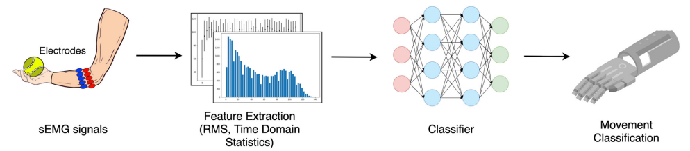

**Fig: Block Diagram of Proposed Method**

Experimentation on the window size shows that the larger the window size is, the higher the performance gain the proposed model achieves, which is expected. Lastly, we measured the running time of our proposed model to compare the feasibility of using different window sizes. We believe that given sufficient data, our proposal could be a feasible approach for controlling advanced prosthetic hands.

The raw signals were divided into sections using a sliding window in order to process real-time sEMG data. The stride between each window was chosen to be less than the window size in order to add more samples and introduce time variation. This led to some overlap between successive samples. The RMS, time-domain statistics as outlined by Hudgins et al. (1993), mean absolute value, mean absolute value slope, zero crossings, slope sign changes, and waveform duration were all collected from each window. To ensure that no characteristic is favoured unequitably over the others due to scale or range, each feature was standardised into a normal distribution.

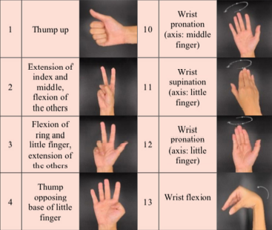

A deep neural network (DNN) has been chosen for dealing with real-world signal processing tasks, due to its outstanding performance compared to other machine learning algorithms (Park and Lee, 2016; Chen et al., 2017; Orjuela-Cañón et al., 2017; Tsinganos et al., 2018; Chaiyaroj et al., 2019). Motivated by this fact and considering our aim for a real-time system, we implemented a simple feed-forward neural network model. The model consists of three hidden layers, which are fully connected layers with 512, 256, and 256 neurons, respectively. All layers were initially assigned random weights using the He uniform initialization scheme.

Data for the rest class was acquired after every hand movement exercise in accordance with the Ninapro data acquisition protocol in order to prevent errors from muscular tiredness brought on by that specific activity. Therefore, in order to deal with the unbalanced data, strong and effective evaluation criteria are required with roughly half of the samples belonging to the rest class.

Otherwise, the outcome would not accurately reflect the model's performance; the model might really do well simply because it only produces the majority class. There is frequently a discrepancy between overall accuracy and balanced accuracy for binary classification problems. One of the most often used metrics, general accuracy, or accuracy for short, measures the proportion of all samples that were properly identified. When there is a class imbalance in the data, this metric may not accurately reflect the performance of the classifier because it does not distinguish samples between classes.

**ADVANTAGES AND APPLICATIONS**

**Advantages:**

1. Proposed CNN based classifier is very good at classification.
2. Proposed classifier takes less time for training.
3. Proposed classifier is very accurate compared to existing classifiers.
4. Feature extraction is includes even the minute details which results in more accurate.

**Applications:**

1. Bio-Medical applications

2. Signal Processing

3. Machine Learning environments

4. Image Processing

**HARDWARE & SOFTWARE REQUIREMENTS:**

**Software:**

• Matlab R2018a.

**Hardware:**

**Operating Systems:**

• Windows 10

• Windows 7 Service Pack 1

• Windows Server 2019

• Windows Server 2016

**Processors:**

Minimum: Any Intel or AMD x86-64 processor

Recommended: Any Intel or AMD x86-64 processor with four logical cores and AVX2 instruction set support

**Disk:**

Minimum: 2.9 GB of HDD space for MATLAB only, 5-8 GB for a typical installation

Recommended: An SSD is recommended a full installation of all Math Works products may take up to 29 GB of disk space

**RAM:**

Minimum: 4 GB

Recommended: 8